Image 1

We start segmenting Image 1. For this image the top two segmentation results from previous projects were from Slic segmentation and WaterShed segmentation.

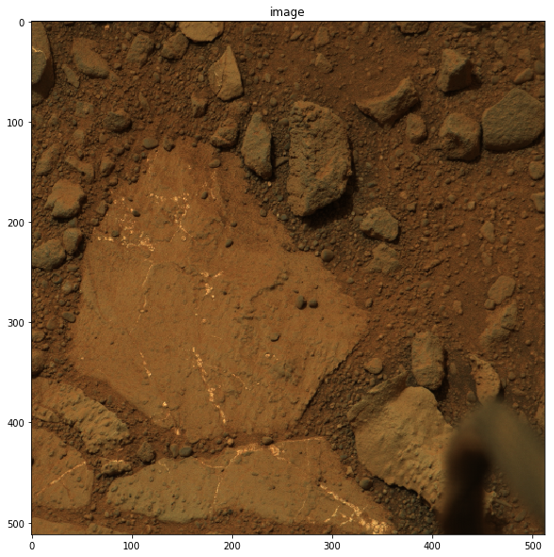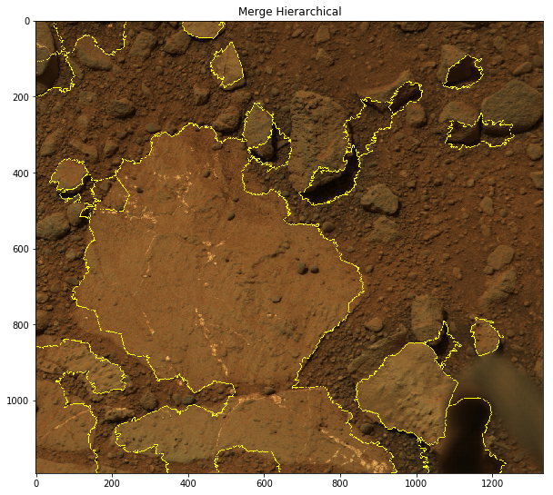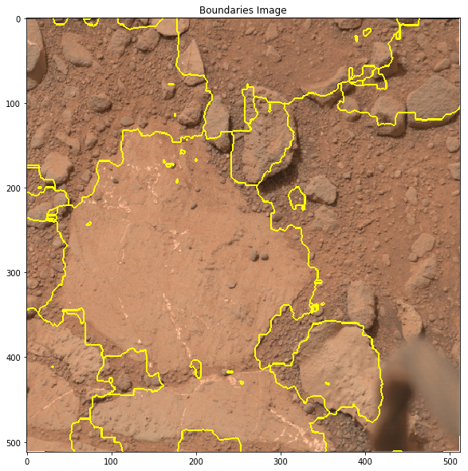

Original Image SLIC+Hierarchical Merging Watershed algo

The slic created over segmentation and later merged the similar edges of the graph using hierarchical merging. The final image created good amount of clusters and separated rock from soil. The watershed algorithm did not work as intended. This is for the fact that there is a part of an instrument in the foreground and the sizes of rocks differ a lot. So it’s easier to oversegment this image than to perform watershed.

The difference in the rock and soil is not significant. So we perform decorrelation stretch to see if we can separate rock and soil. However the lighter shade of rock dominates in the image and darker shades of the rocks are suppressed resulting in mediocre stretch. The stretched image is converted to Lab image to apply slic super segmentation and later merged using hierarchical merging. The number of segments in SLIC0 and merging threshold were varied in range(100,250) and (0.08,0.2) to obtain the result as shown below.

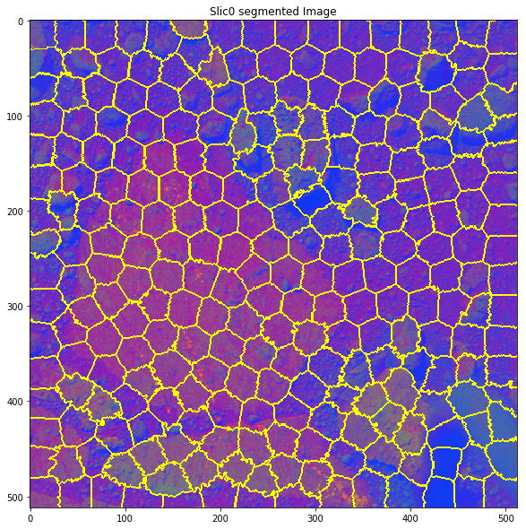 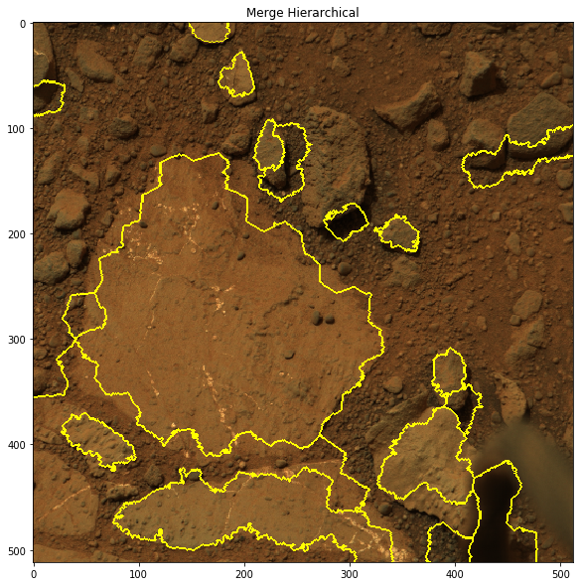

Decorr stretch+ SLIC0 Hierarchical merging

As expected the segmentation was decent but not great. Similarly ran slic algorithm on linearly stretched image to increase the contrast and then performed hierarchical merging based on decorrelation stretched image as shown below.

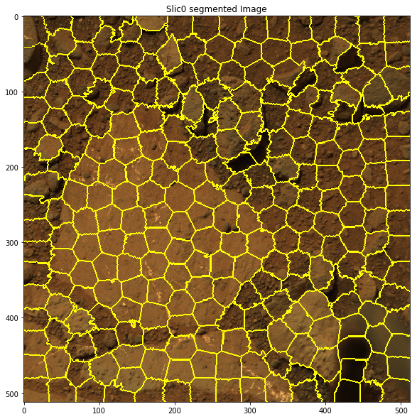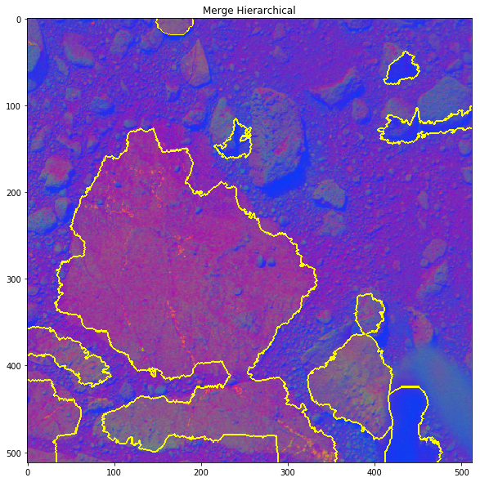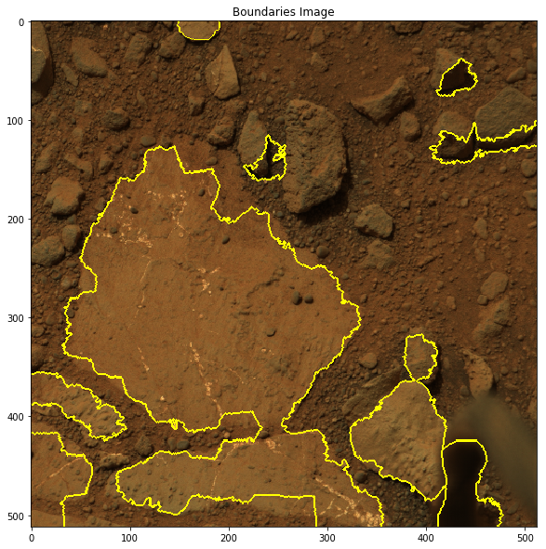

Linear stretch + SLIC0 Decorr stretch + hierarchical merging

Failed Cases:

As you can see from the above result, The segments were decent , so I experimented with following experiment below.

1. DECOR - Kmeans - Merge

Performed a decorrelation stretch on an image to increase the color separation. Used the decorrelated image channels to stack it with linearly stretched channels. Later took a few principal components (n_components=(2,3,4)) using principal component analysis(PCA) to obtain the strongest n_channels. Performed K-means clustering to find the clusters. I performed over-segmentation(increased the number of k) and performed hierarchical merging of the over segmented image. The result is shown below. Again the reason for poor segmentation is because of 3d orientation of some of the rocks(casting shadows) and the foreground rover body part.

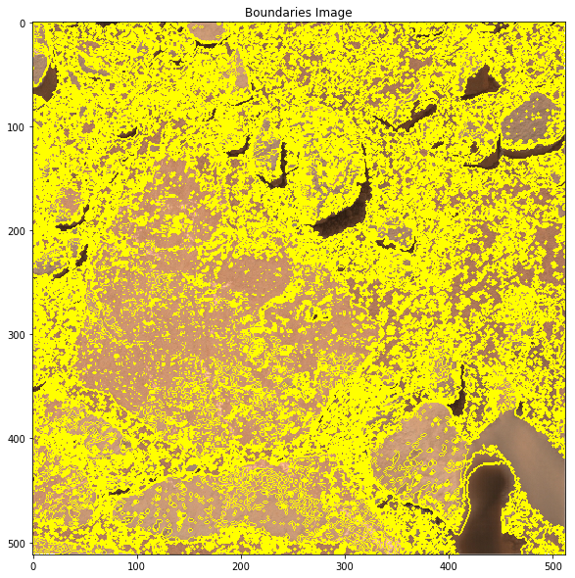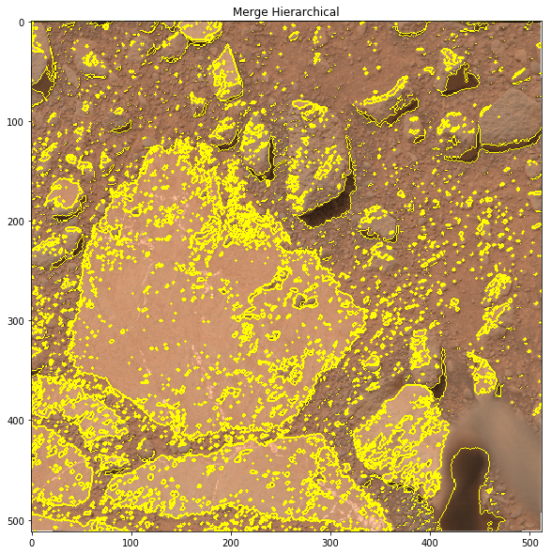

DECOR + Kmeans Hierarchical merging

Image 2

Now we start segmenting Image 2. For this image the top two segmentation results from previous projects were from Felzenszwalb segmentation and WaterShed segmentation.

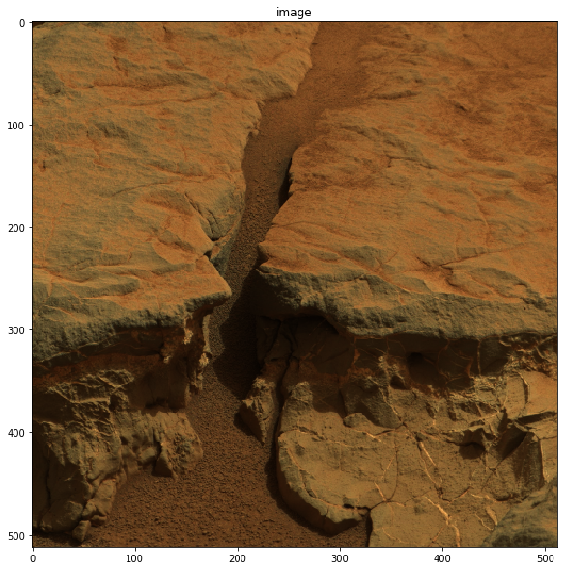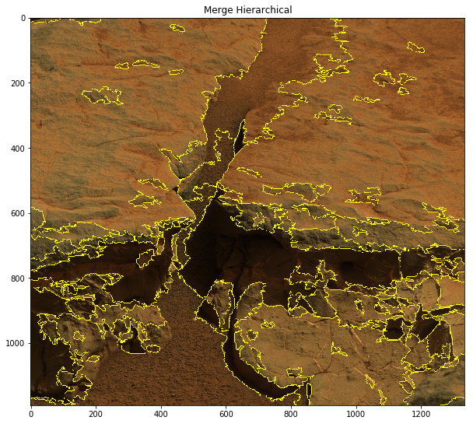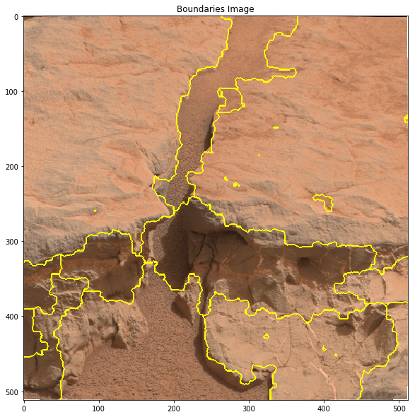

Original Image FH algorithm Watershed algorithm

As the difference between soil and rock on top of the image is not much it’s difficult to get a proper segmentation using FH algorithm. This is because when we perform hierarchical merging it’s difficult to set merging threshold as the edges between the nodes in these regions will have similar weights. This ends up making the segmentation over-segmented or getting bad segments where the soil and rocks at the top merge. Watershed algorithm works well for this image. Maybe this is for the fact that the rocks on either side acts as the catchment basins and the soil acting as watershed line. The watershed algorithm result was already good. So in order to explore new experiments I performed PCA over RGB image to get a single principle component and used this as a gray scale image and fed it to Watershed algorithm. As principal component keeps the most powerful channel among the three, watershed should perform better because now the image has more signal to noise ratio and we know that watershed algorithm performs poorly with noise in image. Had to fine tune the smoothing factors accordingly. The values of smoothing factor was in range (4,16).

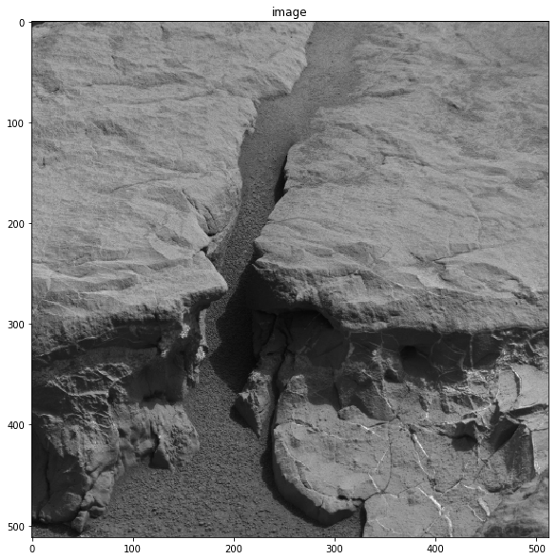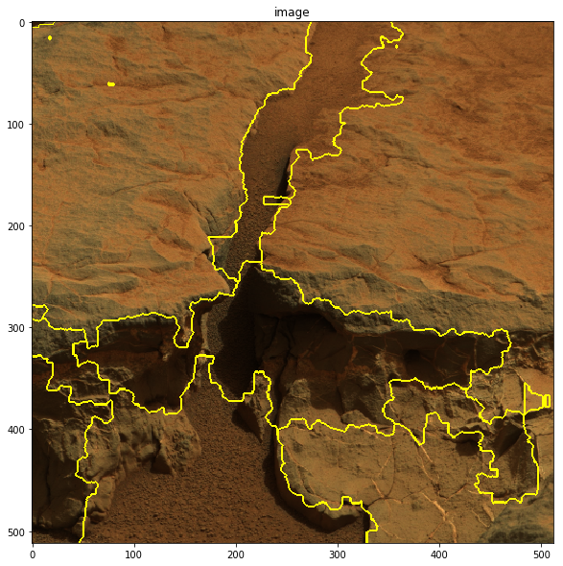 

Principal component WaterShed alg on component 1 Baseline result

We can see that the segmentation is better than the baseline result. There were few segments on the right side rock which is not there anymore so a slight over-segmentation has been taken care of. Oversegmentation happens if there is noise in the image. So with PCA the strongest component with least noise works better. You can see dark region caused by shadow and somewhat white region of the soil in the middle. But this is not separated by the watershed algorithm as shown below.

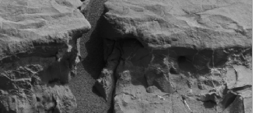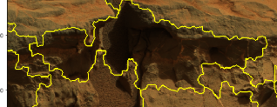

So in an attempt to separate this I performed contrast stretching on the principal component(PC) and ran watershed algorithm. The result is shown below. As we performed contrast stretching I guess some of the noise components were blown up and formed segments. However the result is still better than the over segmented baseline and has some separation as well.

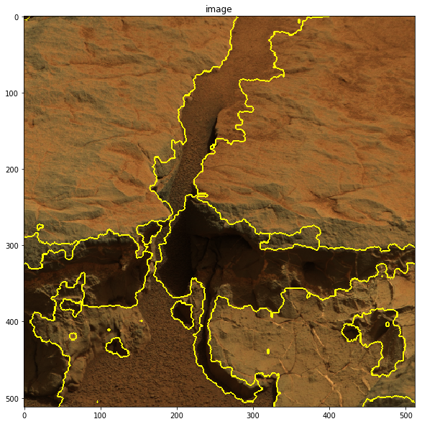 (Contrast stretching + PC)+Watershed PC + Watershed Baseline watershed

Image 3

Now we start segmenting Image 3. For this image the top segmentation result from previous projects were from Felzenszwalb segmentation.

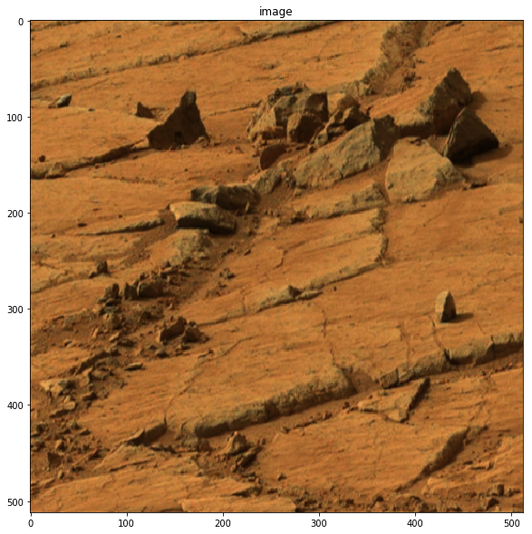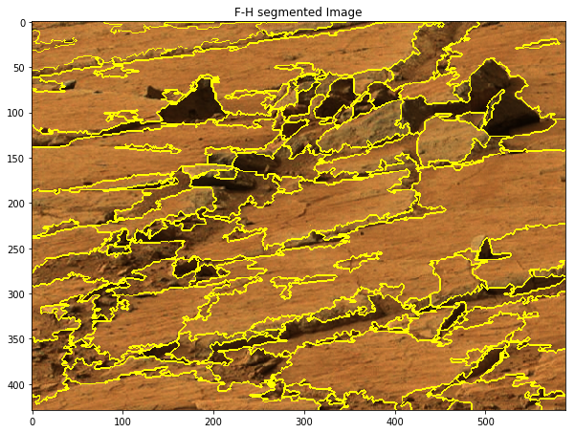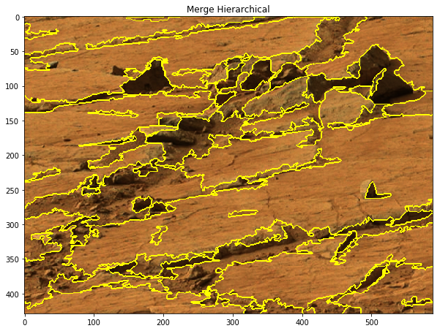

Original Image FH algorithm After Hierarchical merging

The plots above show that the boundaries between rocks and soil is not much. So it’s very difficult to tune the threshold used for hierarchical merging. An attempt to increase the distance is by applying decorrelation stretching and enhancing color separation. The stretched image is shown below.

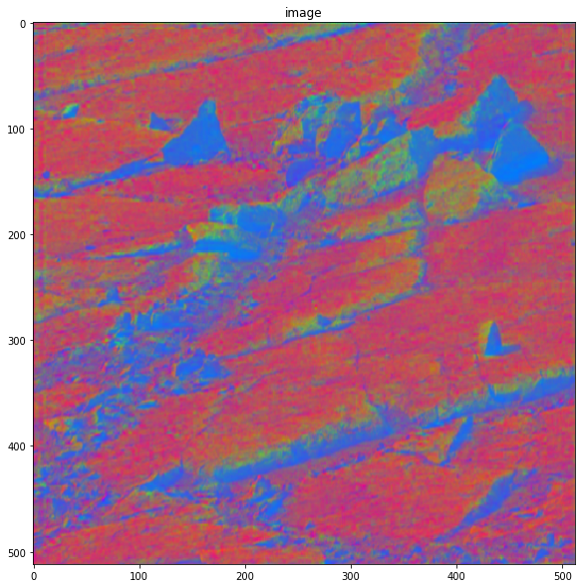

Original Image Decorrelation Stretch

The stretched image is used while doing hierarchical merging. Now the difference between a rock and surface is quite significant. As a result the difference in weight between the nodes became much more prominent. So it became easier to tune the threshold in hierarchical merging. The segmented FH with the merging is shown below.

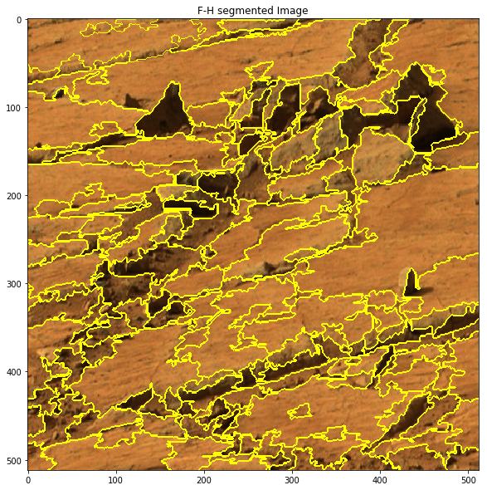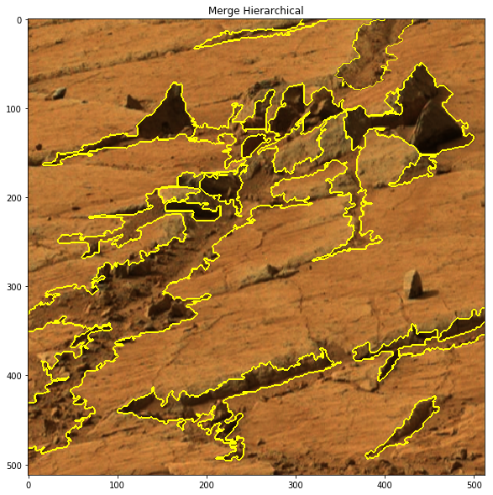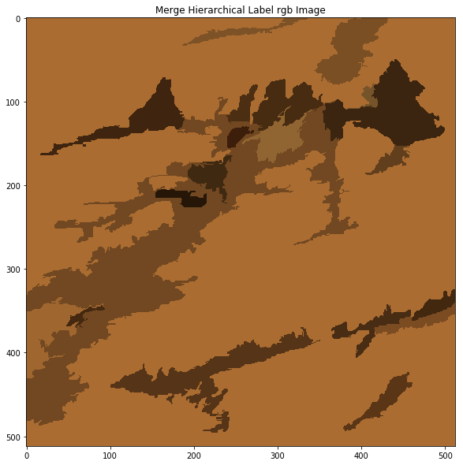

FH segmented Image Decorr stretch + Merging Merging rgb image



Decorrelation Stretch Decorr stretch + Merging Baseline result

As we can see that Decorrelation stretching of the image for merging helps in increasing the distance among segments. The scale, sigma, min_size parameter for FH algorithm was varied in the range (100,300),(0.3,0.7),(100,350). Looking at the results, the number of segments have significantly reduced approximately by 5. The very dark brown in merging rgb image is the rocks and the medium brown is the granular part which goes from left to right of the image. However the horizontal rocks in the image are segmented quite badly. Maybe this is for the fact that other rocks which are darker in color dominated while stretching the image. However smaller part of this rock have also been segmented. Overall the problem of over segmentation was reduced and the result was better than baseline in terms of number of segments.

Image 4

Now we start segmenting Image 4. For this image the top segmentation result from previous projects were from GLCM and watershed segmentation.

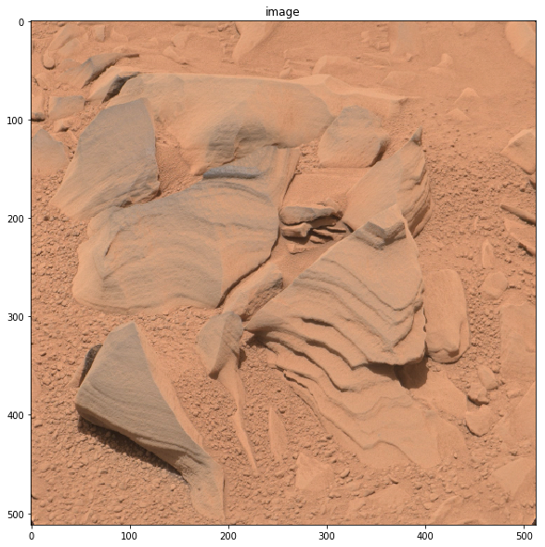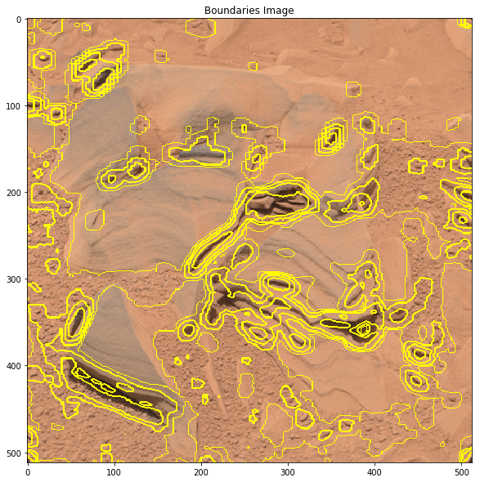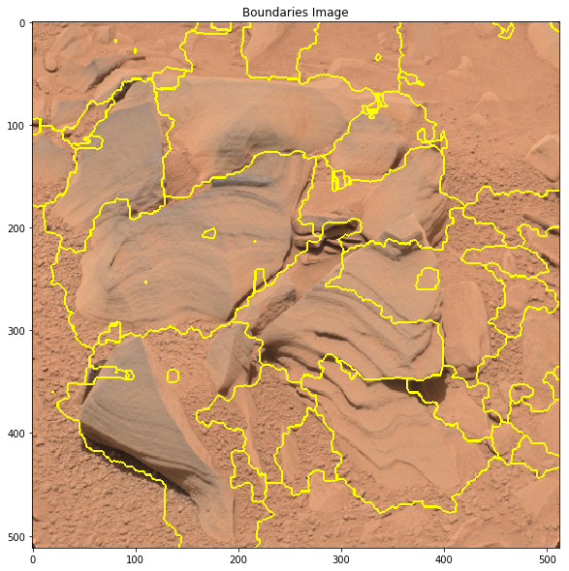

Original GLCM Watershed

The images above show that GLCM did not work well in segmenting. It’s even computational intensive. So I wouldn’t explore GLCM. The image is not suitable for watershed algorithm as well as it will create many segments because of lot of catchment bins. The plots above also show that the boundaries between rocks and soil is not much. If we perform FH segmentation on rgb image it’s very difficult to tune the threshold used for hierarchical merging.

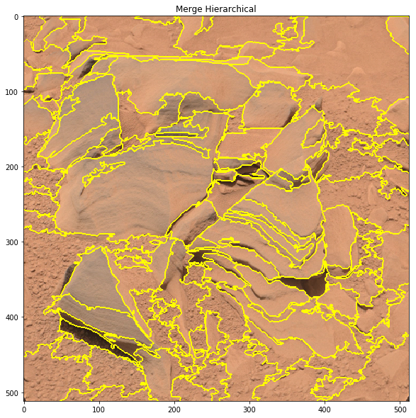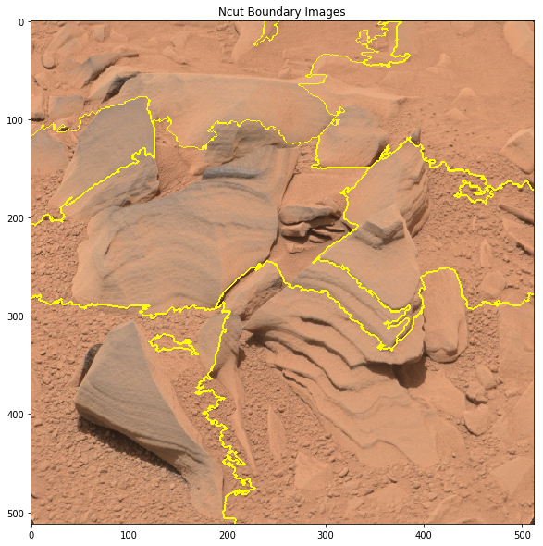

As the distance between soil and rock is not much the FH algorithm fails without decorrelation stretching. An attempt to increase the distance is by applying decorrelation stretching and enhancing color separation.

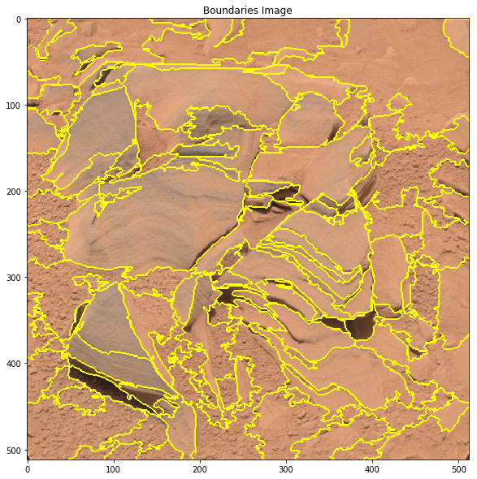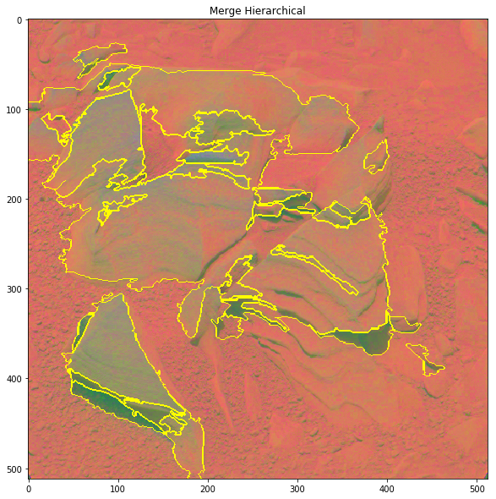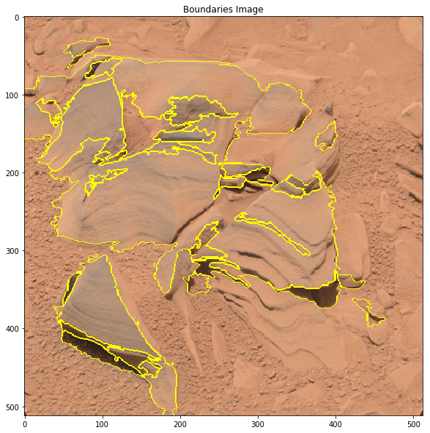

FH-algorithm oversegmented Decorr+Hierarchical merging Decorr+Hierarchical merging

As we can see that Decorrelation stretching of the image for merging helps in increasing the distance among segments. The scale, sigma, min_size parameter for FH algorithm was varied in the range (100,150),(0.5,0.6),(100,250). The number of segments in the image is reduced but the whole of the rock which looks close to soil is not segmented properly. However after decorrelation stretch the segmented result was much better.